Angelou and Douglass – Slavery

(***DO NOT WRITE ON THIS SHEET – ANSWER ON SEPARATE ANSWER SHEET***)

RI/L.7.1 I can refer to the text to support my thoughts and draw inferences about a story/informational text.

- Select: Who is Maya Angelou?
- A freed slave that helped Frederick Douglass escape North to freedom.
- A slave freed by Frederick Douglass.
- The author of the poem “Caged Bird”.
- The author of the short story Tell-Tale Heart.

- Select: Who is Frederick Douglass?
- The author of the autobiography “From Slavery to Freedom”
- The subject of the biography, “From Slavery to Freedom”
- The main character in the short story, “From Slavery to Freedom”
- One of the slaves in the novel, “From Slavery to Freedom”

- Infer: Which inference is the reader most likely to come to after reading Maya Angelou’s “Caged Bird”?
- All slaves long to be free.
- Free men flaunt their freedom openly.
- All slaves sing.
- The slave longs for the free man, but the free man is too busy to notice.

- Conclude: Frederick Douglass valued his education when he was growing up. What evidence from the text supports this conclusion?
- Douglass witnessed many cruelties while on the plantation that he later recorded in his autobiographies.
- In Baltimore, Douglass’s mistress taught him to read until her husband stopped her from continuing.
- After his master said that “learning would spoil” him, Douglass continued his education on his own.
- The collection of speeches in Columbian Orator introduced Douglass to the ideals of the American Revolution.

- Compare: What is the common theme when comparing Maya Angelou’s “Caged Bird” and “Frederick Douglass: From Slavery to Freedom”?
- Both texts are about prominent men who worked to abolish slavery.
- Both texts examine the difficult lives slaves lived and how all men long to be free.
- Both texts were written in the first-person point-of-view.
- Both texts examine historical information about slavery.

RI/L.7.5 I can think about how various sections (sentences chapter, scenes, or stanzas pieces of information and text or literary elements fit into the overall structure and how that affects the development of the ideas in the text.

- Classify: What type of writing is Maya Angelou’s “Caged Bird”?
- Non fiction
- Short Story
- Poem
- Tragedy

- Classify: What type of writing is “From Slavery to Freedom?
- Fiction
- Drama
- Short Story
- Biography

- Analyze: After analyzing the text, why does Maya Angelou include the two stanzas about the free bird in her poem, “Caged Bird”?
- To show the loss the cage bird has experienced.
- To show that the caged bird knows there is a joy to freedom being missed while caged.
- To show how much the caged bird loves the free bird.
- To show that freedom is not always better than a cage.

- Infer: What can the reader infer about the importance of Fredrick Douglass’s oration skills from “Fredrick Douglass: From Slavery to Freedom”?
- Fredrick Douglass’s education was an important part of why he was so influential during the abolitionist movement.
- Being able to intelligently convey his first-hand experience as a slave was a powerful tool for change in the minds and hearts of others.
- Fredrick Douglass conducted secret meetings where he helped others learn how to speak out against slavery.
- Oration skills were required to become part of the abolitionist movement.

- Justify: Justify the following statement with evidence from both texts – All slaves long to be free.
- “Caged Bird” examines the cruelty towards slaves, and “From Slavery to Freedom” examines Douglass’s hardships while seeking freedom.
- “Caged Bird” is a short story about how even though life as a slave can be rewarding, the work is hard and the slaves are trying to get time off for the African holidays, and “From Slavery to Freedom” shows how many slaves escaped slavery to be free to celebrate their African holidays.
- “Caged Bird” says, “The caged bird sings … sings of freedom”; “From Slavery to Freedom” examines the life of Frederick Douglass, his path to freedom, and works as an abolitionist.
- “Caged Bird” shows a slave from a slave owner’s view, but “From Slavery to Freedom” examines the cruelty with which these slave owner’s treated slaves and how this drove the slaves to escape to seek freedom.

RI.7.6 I can figure out an author’s point of view in a piece of informational text and explain how it is expressed in the text.
RL.7.6 I can explain how an author develops the point of view of the narrator or speaker in a text.

- Select: From what perspective is the text “Caged Bird, by Maya Angelou written?
- From the perspective of the caged bird, in 1st person point of view
- From the perspective of the free bird, in 1st person point of view
- From the perspective of the reader, in 2nd person point of view
- From the perspective of an outsider, in 3rd person point of view

- Select: From what perspective is the text “Fredrick Douglass: From Slavery to Freedom” written?
- From the perspective of the author, in 1st person point of view
- From the perspective of the Frederick Douglass, in 1st person point of view
- From the perspective of the reader, in 2nd person point of view
- From the perspective of an outsider, in 3rd person point of view

- Analyze: Because the poem “Caged Bird” is told in 3rd person, analyze what information the reader has that would be left out if it had been told from the perspective of the caged bird?
- What life is like for the free bird.
- How much the caged bird loves the free bird.
- How horrible life is for slaves.
- What life is like for the caged bird.

- Infer: The author’s point of view is that Fredrick Douglass was an important factor in the abolitionist movement. This is evident and expressed in the text because:
- The author explains how Douglass’s efforts helped change many laws regarding slavery and segregation.
- The author gives a first-hand account of Douglass’s efforts towards the abolitionist movement.
- The author gives detailed accounts of each lecture, protest, and rally Douglass initiated in response to slavery.
- The author gives details of Douglass’s ability to eloquently lecture against slavery, his efforts to raise funds to help fugitive slaves, and his part in recruiting troops for the Union Army.

- Compare: After reading and comparing both texts, both authors express the point of view that:
- Slavery should be monitored and those who are enslaved need to be treated more fairly.
- Slavery should be abolished.
- A slave who longs for freedom will be free.
- The life of a slave is dehumanizing and dangerous.

Name: ____________________ Date: _______________ Period: _______
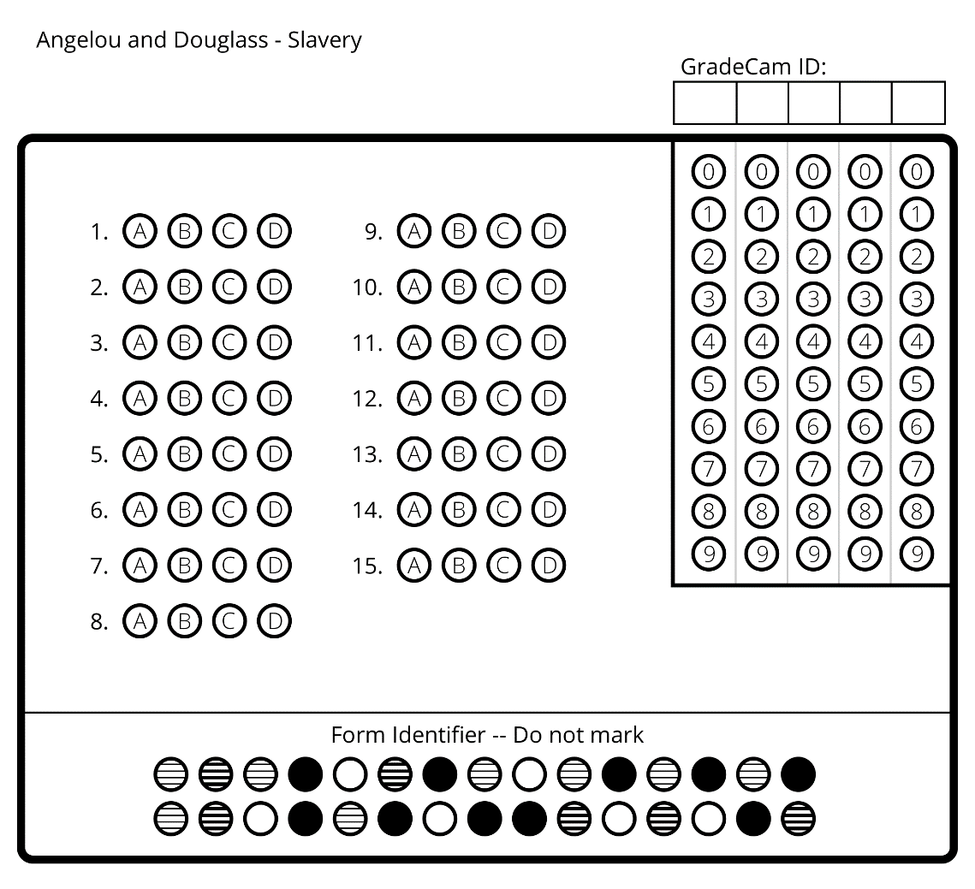
Name: ____________________ Date: _______________ Period: _______
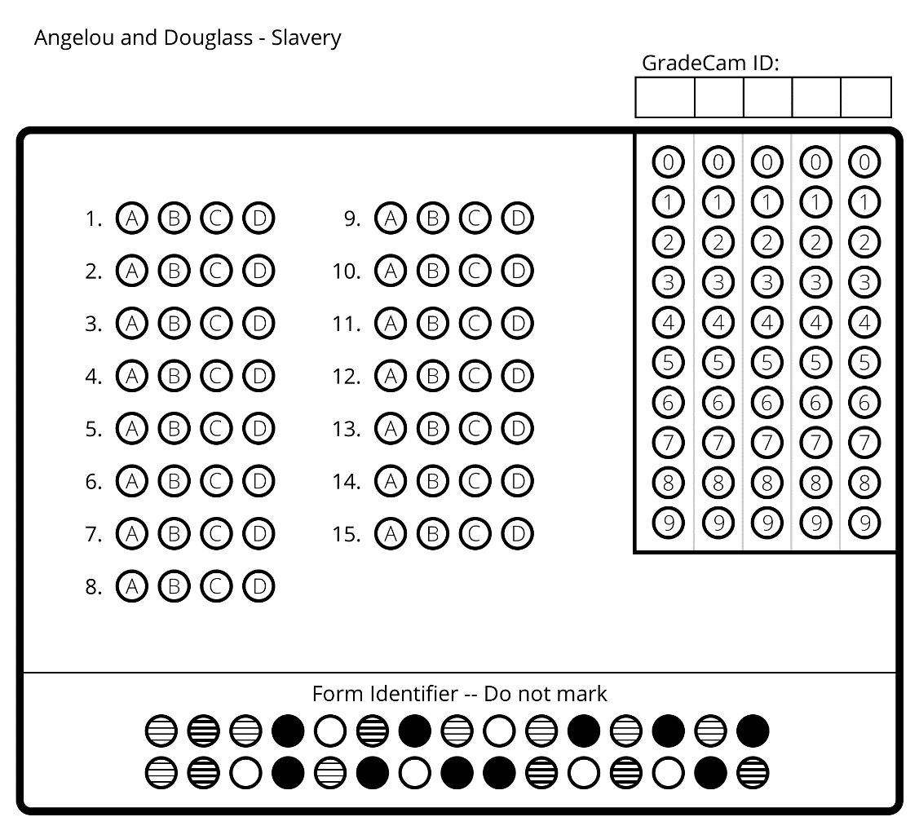

ANGELOU and DOUGLASS – SLAVERY (Key)

- C
- B
- A
- C
- B
- C
- D
- B
- B
- C
- D
- D
- A
- D
- B

